Implementation Neon Box At Polbeans Coffee
M. Nur Faizi¹, Muharnis², Hardi B³, Rosnani Binti Affandi⁴, Ameelia Binti Ibrahim⁵
^{1,2,3}Teknik Elektro, Politeknik Negeri Bengkalis, Indonesia, Politeknik Melaka
faizi@polbeng.ac.id¹, muharnis@polbeng.ac.id², hardi@polbeng.ac.id³, rosnani_affandi@polimelaka.edu.my⁴, ameelia@polimelaka.edu.my⁵

Abstract
The development of digital information and communication technology has driven an increasing need for fast, dynamic, and visually appealing information delivery media. One technology that can meet these needs is the neon box, a digital display media based on LED panels that can display character writing in real-time. This study aims to implement character writing in the incubator room of Bengkalis State Polytechnic as a background or photo media to make it look attractive and allow for product promotions and other general publications. The research methodology includes several stages, namely literature studies related to neon box components, system design, hardware selection, installation process, control system integration, and testing the performance of neon boxes in indoor and outdoor environments. The main devices used include indoor and outdoor LED lights, a 5V/50A power supply. This system is designed to receive content input from various sources via wired or wireless connections, then transmitted and processed by a video processor to be displayed optimally on the LED panel. With this implementation, it is hoped that the neon box can become a digital display media based on LED panels that can display character writing in real-time, while also providing inspiration for the development of other digital information media based on electronic technology.

Keywords : Neon Box, Display, Real Time, LED.

- INTRODUCTION
In today's digital era, the need for fast, efficient, and engaging information delivery has become crucial across various sectors, including education. Universities, as institutions of higher learning, are required to continually keep up with technological developments to support the learning process and information management. One rapidly developing and widely adopted technology is the neon box. Neon boxes are a Light-Emitting Diode (LED)-based visual information display medium capable of displaying character text, images, advertisements, and more in real time.
The use of neon boxes is now widely found in public spaces such as highways, shopping centers, cafes, stadiums, and educational institutions. In the context of advertising or promotion, the use of neon boxes can increase the attractiveness and effectiveness of conveying information to visitors who come to a place, one of which is the incubator of the Bengkalis State Polytechnic. A Business Incubator is an ethic or program designed to help develop the initial growth of a company by providing a supportive environment for business support resources to help startups grow and succeed. The Business Incubator, which is a collaboration between the Bengkalis State Polytechnic and the Bengkalis Regency Tourism, Culture, Youth and Sports Office (Disparbudpora), is one of the media in developing new entrepreneurs that provides educational assistance, training and internships supported by technological facilities.
In addition, the transition from conventional printed promotional media to electronic-based display systems has become increasingly important in modern business environments. Printed banners and static signage have limitations in durability, flexibility, and visual impact, particularly in spaces that emphasize creativity and innovation such as business incubators.
LED-based neon box technology offers an alternative solution that combines visual attractiveness, energy efficiency, and long operational lifespan. Compared to traditional neon lighting, LED neon boxes consume less power, generate lower heat, and are environmentally friendly. These advantages make them suitable for long-term installation in indoor and outdoor settings.

Therefore, the implementation of neon boxes in educational business incubators is not only a technological upgrade but also a strategic effort to support branding, promotion, and creative atmosphere development. This study contributes to the practical implementation of LED-based display systems in an academic incubator context, which has received limited attention in previous research.
This research aims to implement character writing in the incubator room of Bengkalis State Polytechnic as a background or media for taking photos to make it look attractive and allow for product promotions and other general publications. During the process, display performance, device reliability under environmental conditions, and the effectiveness of overall system integration are tested. This testing is crucial to ensure the system operates properly and meets expected quality standards.

- REVIEW OF LITERATURE

According to research conducted by Setya and colleagues entitled Design and Construction of Indoor LED Videotron Screens with HD-U60-75 Microcontrollers. This study determines the current generated from six variations of background colors and panel variations in series. The results obtained indicate that color variations and the number of panels used affect the current source. The test results show that White has the highest current consumption of 4.972 A, yellow is 4.370 A, purple is 3.948 A, light blue is 3.622 A, green is 2.786 A, red is 2.780 A, and blue has the lowest current consumption of 1.350 A (Setya et al., 2022).
Sayekti and his colleagues have created a Videotron as an Information Media in the Electronics Laboratory, a Raspberry Pi 3B+-based information media in the form of text, images, and videos whose data is sent via Wi-Fi from an application built on a smartphone. The Videotron is assembled using a 16 x 32 P10 RGB SMD Dot Matrix which is formed into a screen measuring 2 meters long and 1 meter wide. Other important components in the system are the RGB LED Matrix panel drive board and a 5 Volt switching power supply. Test results for the display on the videotron screen must be set with different resolutions for each type of data sent to get the best results. For data in the form of images, the best results are 2250 x 4000 pixels, while for video, the access speed is greatly influenced by the availability of the internet network. This system entirely absorbs a maximum power of 300 Watts (Sayekti et al., 2023).
According to research conducted by Muhdi and colleagues, entitled "Design and Construction of a Microcontroller-Based Videotron Display Information Tool," this study designed an information update tool for electronic information boards using a microcontroller-based videotron display. This system is useful for changing or updating information at any time. This system utilizes a microcontroller that can be programmed using PowerLED software. Various types of information can be displayed, including text, clocks, images, and audio-video. Test results show that data transmission is limited to a range of no more than 30 meters, and the results of display simulation tests are 100% in accordance with the given commands. (Muhdi et al., 2021).
According to research conducted by Yuhanas and friends on the design of running text using the P10 LED matrix module based on Arduino Uno. Writing text on the LED matrix using a computer or via Bluetooth on an Android smartphone has limitations in terms of distance and is less efficient so it needs to be replaced using a Wifi network. The tool manufacturing stage uses the ESP8266 module, Arduino Uno ATMega 328 for the control center on the display information board, RTC DS3231 as a timer to display the hour, day, date, month, and year that will be displayed by the running text. Then to input information text using an Android smartphone application with a wifi connection, then the text is received by the ESP8266 module which is forwarded to the Arduino Uno ATMega 328 to be displayed on the running text which can be letters, numbers, and punctuation. From five tests with 28-80 characters, the delay time obtained is between 0.64 seconds to 2.19 seconds under normal tool conditions. The reliability of the tool was tested for 3 days with data transmission every 8 hours, resulting in the fastest transmission time recorded at 6.03 seconds in the first 8 hours, and the longest time at 7.11 seconds in the eighth 8 hours (Yuhanas et al., 2021).
Based on the references above, researchers will conduct a study entitled "Implementation of Neon Boxes in the Bengkalis State Polytechnic Incubator Room." This system will be applied indoors and outdoors at the cafe where the Bengkalis State Polytechnic incubator is located. The system aims to replace conventional (printed) banners used as backdrops or photo spots.

- METHOD
The model used in this study is shown in the block diagram in Figure 1.

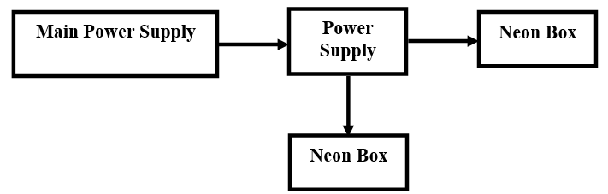
Fig. 3. Block diagram of the Implemented Research

Figure 1 shows that the main power supply is the power source. The power supply supplies DC voltage to the HD-VP620 controller and the neon box module. The neon box module uses an LED type designed in the form of character writing made of acrylic. The neon box frame is made of iron plate, and the neon box cover is made of aluminum composite panels. This operating system is very easy because it's pre-arranged.
A. Research Design
This study employed an applied engineering research design with an emphasis on the practical implementation and evaluation of an LED-based neon box system. The primary objective of this research was not to develop new theoretical models, but rather to design, construct, and assess the performance of a functional display system that can be directly applied in a real-world environment, specifically within the business incubator area of Bengkalis State Polytechnic.
The applied research approach was selected because the study focuses on solving a practical problem, namely the replacement of conventional printed promotional media with a more attractive, durable, and technologically advanced digital display. The research process involved system planning, hardware selection, physical implementation, and performance testing. Data collection was conducted through direct measurement, observation, and functional testing of the installed system.
Performance evaluation was carried out by analyzing electrical stability, display quality, and operational reliability under actual usage conditions. This approach allows the research outcomes to provide practical contributions and technical references for future implementations of neon box or LED-based display systems in educational and commercial environments.
B. Hardware Components
The neon box system implemented in this study consists of several main hardware components, including LED lighting modules, a display controller, a power supply unit, acrylic character panels, aluminum composite panels (ACP), and a metal frame structure. Each component was selected based on functionality, durability, and compatibility with indoor and outdoor applications.
The LED lighting used in this system is an energy-efficient LED strip designed to produce high brightness with low power consumption. LEDs were chosen due to their long operational lifespan, stable illumination characteristics, and minimal heat generation compared to conventional neon lighting. The display controller used in this system functions as the central control unit, managing the power distribution and display operation to ensure consistent lighting performance.
The power supply unit converts 220 V AC input voltage into a stable low-voltage DC output required by the LED modules. A high-current power supply was selected to ensure sufficient electrical capacity and voltage stability during continuous operation. For the visual structure, acrylic material was used to form the character writing due to its light diffusion properties, durability, and aesthetic appeal. Aluminum composite panels (ACP) were used as the outer cover because of their resistance to corrosion, lightweight structure, and suitability for both indoor and outdoor installations. The frame structure was constructed using metal plates to provide mechanical strength and stability, ensuring the neon box remains securely mounted during long-term use.
C. Installation Procedure
The installation process of the neon box system was carried out in several systematic stages to ensure proper functionality and safety. The first stage involved the design and layout planning, where the size, character arrangement, and placement location of the neon box were determined according to the available space in the incubator area. Electrical load calculations and mounting positions were also planned at this stage.
The second stage involved electrical wiring and component assembly. The LED modules were installed behind the acrylic character panels, and wiring connections were made between the LED modules, the controller, and the power supply unit. All electrical connections were insulated and arranged neatly to minimize the risk of short circuits and ease future maintenance.
The third stage was mechanical mounting, where the neon box frame was securely attached to the wall structure using appropriate fasteners. The aluminum composite panel was installed as the protective cover, and the acrylic character panels were mounted on the front side of the frame. Finally, the system underwent initial functional testing, during which the power supply was activated, and the LED lighting performance was observed to ensure all components were operating correctly before full deployment.
D. Testing Procedure
The testing procedure in this study consisted of electrical testing, visual performance inspection, and reliability evaluation. Electrical testing focused on measuring the input and output voltage of the power supply using a digital multimeter. Measurements were taken multiple times to evaluate voltage stability under normal operating conditions.
Visual inspection was conducted to assess brightness uniformity, clarity of character writing, and overall display appearance. The neon box was observed under different ambient lighting conditions, including daylight and nighttime environments, to evaluate visibility and readability. Any signs of flickering, uneven illumination, or color inconsistency were noted during this process.
Reliability testing was performed by operating the neon box continuously over an extended period in both indoor and outdoor environments. The system was monitored for overheating, power instability, and mechanical issues. The absence of functional failure during the testing period indicates that the neon box system is reliable and suitable for long-term use as a promotional and informational display medium.

- RESULT & DISCUSSION
4.1 Result
The manufacturing process begins with creating a power supply circuit to control the neon box. The power supply used is a single-phase, or 220-volt AC, input with a 12-volt DC output. The design results in this research are in the form of a series of neon box panels as shown in Figure 2 and 3.

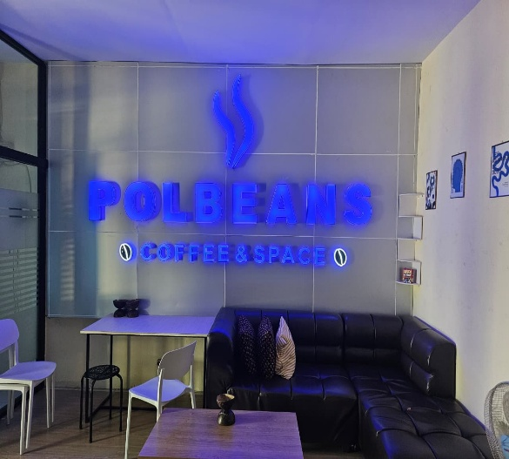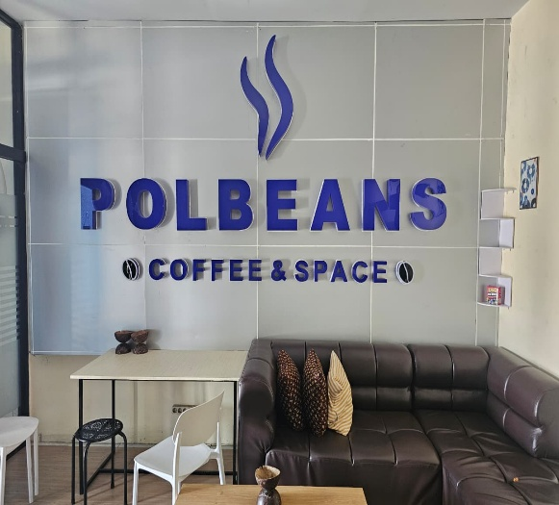
Fig. 2. Neon Box Panel at Polbeans Coffee Indoor

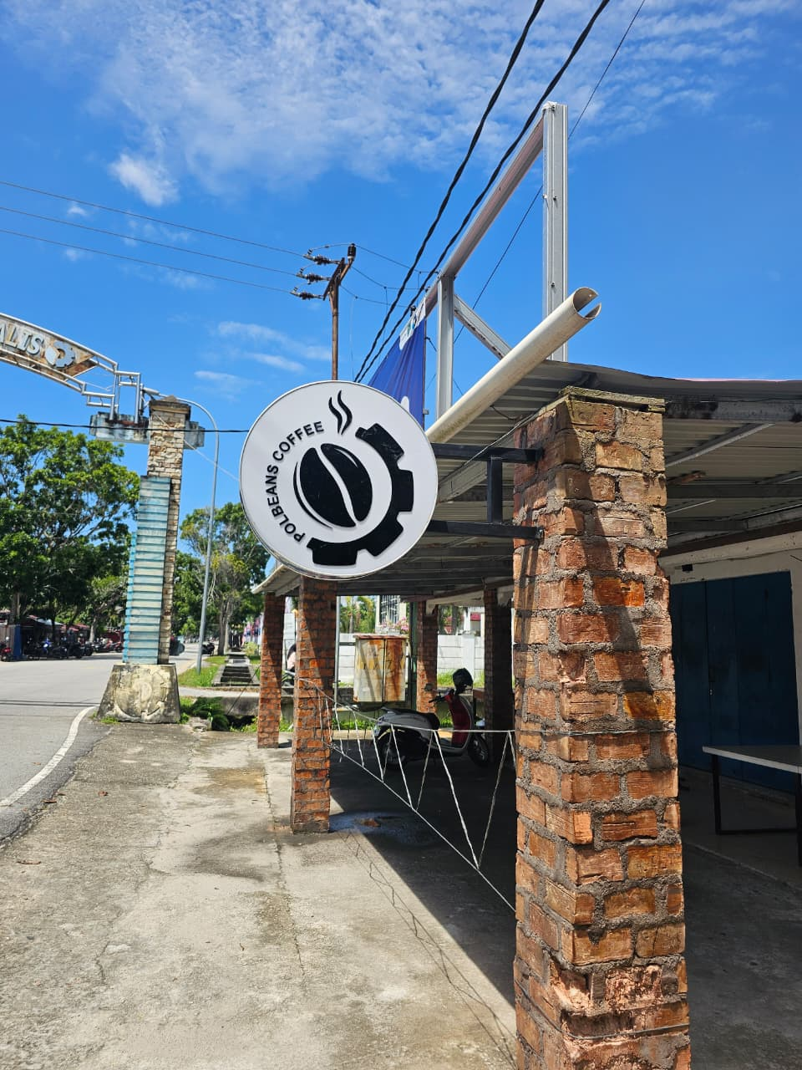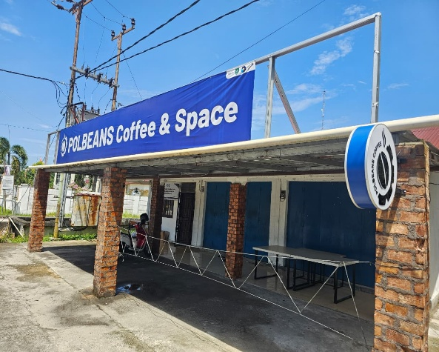
Fig. 2. Neon Box Panel at Polbeans Coffee Outoor

The tests carried out in this study were in the form of control panel output data as shown in Table 1.

Table 1. Testing Value
No | Input (V AC) | Output (V DC) | Condition
1 | 227 | 12 | Normal
2 | 225 | 11.8 | Normal
3 | 226 | 11.9 | Normal
4 | 227 | 12 | Normal
5 | 226 | 12 | Normal

  - Discussion
A. System Implementation Discussion
The implementation of the neon box system at the Polbeans Coffee incubator area was carried out in two environments, namely indoor and outdoor locations. The system consisted of an LED-based neon box module, an HD-VP620 controller, and a 5V/50A power supply, integrated with acrylic character panels and an aluminum composite panel (ACP) frame. The installation process was completed successfully, and the system was able to operate continuously during testing without functional failure.
Visually, the neon box was able to display character writing clearly with high brightness and uniform light distribution. The use of acrylic lettering combined with LED illumination resulted in sharp text contours and good readability from various viewing distances. Indoor installation produced more stable visual performance due to controlled lighting conditions, while outdoor installation demonstrated sufficient brightness to remain visible during daylight and night-time conditions.
These findings indicate that the selected hardware components and structural materials are suitable for both indoor and semi-outdoor applications, particularly in commercial or educational incubator environments.

B. Electrical Performance Testing
Electrical performance testing focused on measuring the stability of the power supply output under normal operating conditions. The test results are summarized in Table 1.
Based on the testing results, the input voltage ranged between 225 V and 227 V AC, while the output voltage remained relatively stable between 11.8 V and 12 V DC. These values fall within acceptable tolerance limits for LED-based display systems.
The stable output voltage indicates that the power supply is capable of delivering sufficient and consistent electrical power to the neon box system. Voltage stability is crucial because fluctuations may cause brightness inconsistency, flickering, or long-term degradation of LED components. During the testing period, no such disturbances were observed, suggesting that the system is electrically reliable for continuous operation.
When compared with previous studies such as Setya et al. (2022), which reported variations in current consumption depending on LED color composition, this study focused more on voltage stability rather than current variation. However, maintaining a stable voltage is a fundamental requirement for ensuring optimal LED performance regardless of color configuration.

C. Display Performance Analysis
From a display performance perspective, the neon box demonstrated good clarity, brightness, and aesthetic appeal. The character-based design allowed information to be communicated in a simple yet visually attractive manner. Unlike videotron systems that rely on pixel matrices, the neon box emphasizes fixed textual branding, making it particularly suitable for identity reinforcement and promotional backdrops.
In comparison with videotron-based systems developed by Sayekti et al. (2023) and Muhdi et al. (2021), the neon box system has lower complexity, reduced power consumption, and simpler operational requirements. While videotrons support dynamic multimedia content such as videos and animations, neon boxes offer advantages in terms of durability, ease of maintenance, and cost efficiency.
Furthermore, the neon box does not require continuous internet connectivity or frequent content updates, which makes it suitable for long-term branding applications in incubator spaces, cafes, and educational facilities.

D. Environmental and Reliability Testing
Environmental testing was conducted by operating the neon box system continuously over several hours in both indoor and outdoor settings. The system remained functional without overheating, flickering, or noticeable brightness degradation.
Outdoor installation exposed the neon box to ambient temperature changes and indirect sunlight. The aluminum composite panel (ACP) housing effectively protected internal components, while the acrylic cover helped diffuse light evenly. This result supports findings by Yuhanas et al. (2021), who emphasized the importance of structural design and environmental protection in LED display systems.
Reliability testing results suggest that the neon box can operate for extended periods with minimal maintenance, making it a practical solution for business incubators and commercial branding spaces.

E. Functional Effectiveness in Business Incubator Context
From a functional perspective, the neon box serves not only as an information display but also as a branding and promotional medium. In the Polbeans Coffee incubator environment, the neon box functioned as a photo backdrop and visual identity element, enhancing the aesthetic value of the space.
The presence of a visually attractive neon box is expected to increase visitor engagement, social media exposure, and brand recognition. Although this study did not quantitatively measure customer perception or engagement metrics, observational evidence suggests that the neon box contributes positively to the overall ambience of the incubator area.
Future research could extend this work by incorporating user satisfaction surveys or engagement analytics to quantitatively evaluate promotional effectiveness

- CONCLUSION
Neon boxes can promote businesses, enhance branding, and enhance the appearance of business premises by attracting attention with their bright lighting at night and clear lettering. Another advantage is that they can be an effective long-term promotional medium, both day and night, and help build a strong visual identity for a brand. This study successfully implemented an LED-based neon box system in the Polbeans Coffee incubator area at Bengkalis State Polytechnic. The system demonstrated stable electrical performance, reliable operation, and visually attractive display results in both indoor and outdoor environments.
The neon box proved effective as a long-term promotional and branding medium, offering advantages in durability, energy efficiency, and aesthetic value compared to conventional printed media. The stable power supply output ensured consistent brightness and minimized the risk of component degradation.
Overall, the implementation confirms that neon box technology is a practical and cost-effective digital display solution for educational business incubators. Future studies are recommended to incorporate quantitative user perception analysis and energy consumption measurements to further evaluate system effectiveness.

- REFERENCES

Chen, J., & Luo, X. (2020). Design and implementation of LED display systems for indoor and outdoor applications. International Journal of Electrical and Computer Engineering, 10(4), 3891–3899.
Muhdi, Hariyanto, R., & Widodo, A. A. (2021). Ancang Bangun Alat Informasi Terdisplay Videotron Berbasis Mikrokontroler. Jurnal SPIRIT, 13(1), 40–43.
Sayekti, I., Supriyati, Sasongko, Hidayati, U., Pamungkas, A. W., Prasetyo, I. A., Chairul, M. B., & Putri, T. A. S. (2023). Rancang Bangun Videotron Berbasis Raspberry Pi Sebagai Media Informasi Di Laboratorium Elektronika. Jurnal ORBITH, 19(1), 1–8.
Setya, W., Fariha, & Chusni, M. M. (2022). Indoor LED Videotron Screen Design With Microcontroller HD-U60-75. Berkala Fisika Indonesia : Jurnal Ilmiah Fisika, Pembelajaran Dan Aplikasinya, 13(2), 57–64.
Yuhanas, M., Hadi, C. F., & Lestari, R. F. (2021). Rancang Bangun Running Text Menggunakan Modul Led Matrix P10 Berbasis Arduino Uno Di Fakultas Teknik Universitas Pgri Banyuwangi. Journal Zetroem, 3(2), 16–22.

